**EXPERIMENT 9**

**REGRESSION METHODS**

**1. Exponential Regression Method**

Ques:

|  |  |  |  |  |  |
| --- | --- | --- | --- | --- | --- |
| x | 1 | 2 | 3 | 4 | 5 |
| y | 1.6 | 4.5 | 13.8 | 40.2 | 125 |

**CODE**

clc

clear all

%y=a*e^(b*x)

%logy = loga + b*x

n=input('enter the number of data values: ');

x=input('enter data for x: ');

y=input('enter data for y: ');

for i=1:n

Y(i)= log(y(i));

end

a=0;b=0;c=0;d=0;

for i=1:n

a=a+x(i);

b=b+Y(i);

c=c+x(i)*Y(i);

d=d+x(i)*x(i);

end

A=[n,a;a,d]

C=[b;c]

B=inv(A)*C

slope=B(2,1)

a1=exp(B(1,1));

intercept=a1

y = intercept * exp(slope*x);

plot(y,x)

**OUTPUT**

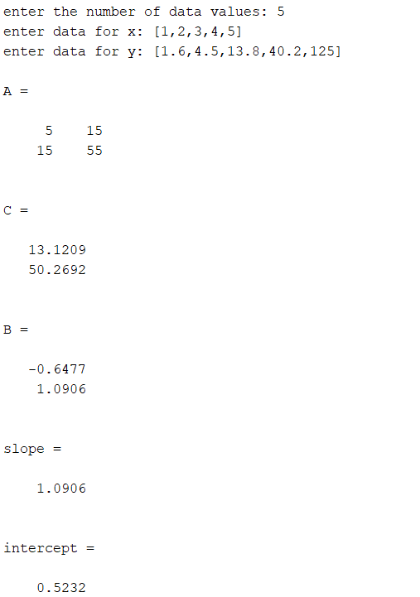



**GRAPH**



**2. Logarithm Regression Method**

Ques:

|  |  |  |  |  |  |
| --- | --- | --- | --- | --- | --- |
| x | 1 | 2 | 3 | 4 | 5 |
| y | 1.6 | 4.5 | 13.8 | 40.2 | 125 |

**CODE**

clc

clear all

%y=a*(b^x)

%logy = loga + x*logb

n=input('enter the number of data values: ');

x=input('enter data for x: ');

y=input('enter data for y: ');

for i=1:n

Y(i)= log(y(i));

end

a=0;b=0;c=0;d=0;

for i=1:n

a=a+x(i);

b=b+Y(i);

c=c+x(i)*Y(i);

d=d+x(i)*x(i);

end

A=[n,a;a,d]

C=[b;c]

B=inv(A)*C

slope=exp(B(2,1))

intercept=exp(B(1,1))

y = intercept *((slope).^x);

plot(y,x)

**OUTPUT**

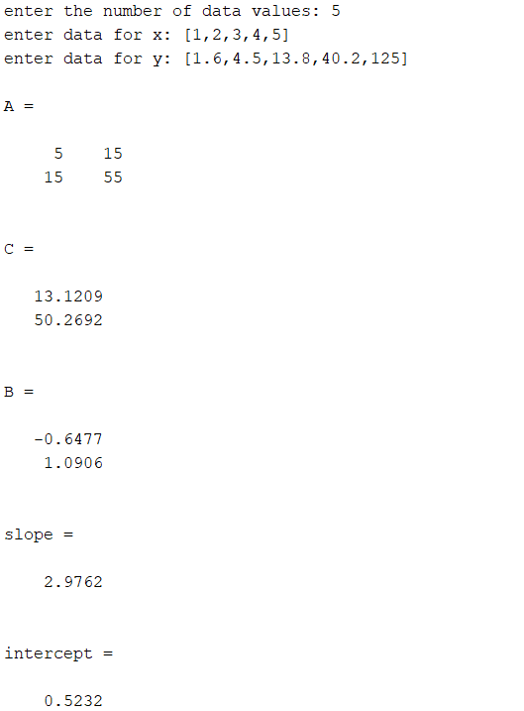



**GRAPH**

